**BOOK COVER USING CANVA**

INTRODUCTION:

1.1 OVERVIEW:

Try and make a short summary of the book to get a clearer idea. Another thing that might work for you is listing down words that immediately remind you of your book, which indirectly means that you want the reader to feel the same way.

1.2 PURPOSE:

The purpose of book cover design is to draw the attention of your potential readersaway from all those other tomes and novellas and sell them on the idea that your page-turner is the next book they need on their nightstand.

Yes, you can use Canva to create book covers for commercial purposes. Canva offers a wide range of templates and design elements that you can use to create professional-looking book covers. You can also use your own images, graphics, and text to customize the design to your specific needs.

PROBLEM DEFINITION AND DESIGNING THINKING:

2.1 EMPATHY MAP:

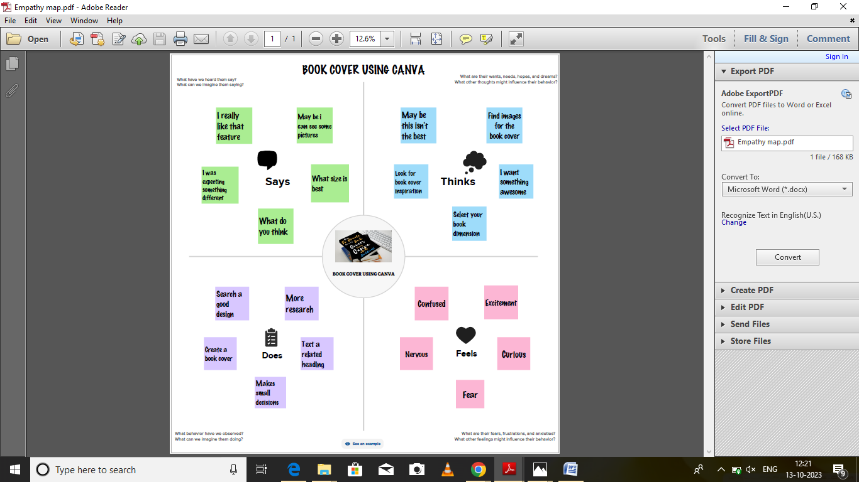

2.2 IDEATION AND BRAINSTORMING:

# 

3.RESULT:

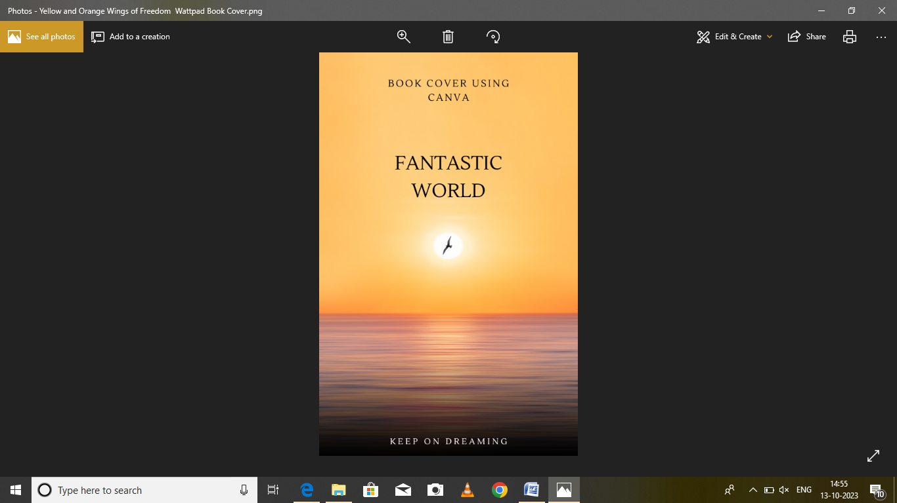

4.ADVANTAGE AND DISADVANTAGE:

Canva's collection of book cover layouts is the best on the web! Our team of awesome designers have worked hard to create quality layouts which will help your book look professional and sell out. You won't need to spend hundreds hiring a designer when you create your own awesome cover in Canva's book cover maker. Depending on where you are at in your business, Canva’s appeal will be different. I.e. the benefits could outweigh the limitations if you are a small business owner, start-up, or professional individual, with budget limitations and limited access to a designer. However, for design professionals, and larger companies who need greater control over their content in terms of consistency and IP, Canva might not be for you.

5.APPLICATIONS:

* Select a template. Explore Canva's wide range of book cover designs for your self-publishing needs.
* Customize your book cover design.
* Try out different features.
* Publish and share

6.CONCLUSION:

**CANVA** can be used for **book covers**! Here's how: First, go to **Canva**.com and create a free account. Then, click on the “Create a design”